IP Prefix
# Source: AI Source: Provided by: [Data Path: Persons Table -> ID Column: 1, Name_En Column: Motasem Essam] -> From: [ChatGPT] on [1/18/2026]
An IP prefix is a range of IP addresses that is identified by a starting IP address and a prefix length, written in CIDR (Classless Inter-Domain Routing) notation.
It tells routers which block of IP addresses belongs to a specific network or Autonomous System (AS).

🧠 Simple Definition:
# Source: AI Source: Provided by: [Data Path: Persons Table -> ID Column: 1, Name_En Column: Motasem Essam] -> From: [ChatGPT] on [1/18/2026]
An IP prefix defines a network block, like 192.168.0.0/24, meaning 256 IP addresses starting from 192.168.0.0.

🧾 Format
# Source: AI Source: Provided by: [Data Path: Persons Table -> ID Column: 1, Name_En Column: Motasem Essam] -> From: [ChatGPT] on [1/18/2026]
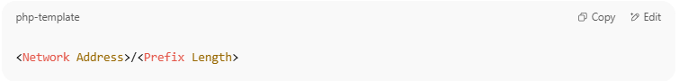
<Network Address>/<Prefix Length>

- Example: 203.0.113.0/24
  - 203.0.113.0 = starting IP
  - /24 = subnet mask (first 24 bits are the network portion)
  - Covers IPs from 203.0.113.0 to 203.0.113.255

📦 How IP Prefixes Are Used in BGP and Routing
# Source: AI Source: Provided by: [Data Path: Persons Table -> ID Column: 1, Name_En Column: Motasem Essam] -> From: [ChatGPT] on [1/18/2026]
- IP prefixes are announced in BGP so routers on the internet know how to reach specific networks.
- Each prefix is owned and advertised by an AS (Autonomous System).
- Routing tables store these prefixes and match them with the most specific prefix (longest match rule).

🌐 Example (in BGP):
# Source: AI Source: Provided by: [Data Path: Persons Table -> ID Column: 1, Name_En Column: Motasem Essam] -> From: [ChatGPT] on [1/18/2026]
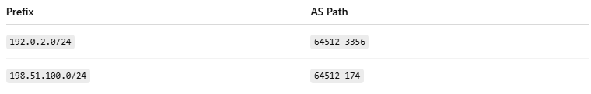

Prefix | AS Path
192.0.2.0/24 | 64512 3356
198.51.100.0/24 | 64512 174
- These prefixes tell routers where to send traffic destined for those IP blocks.

🗃️ IP Prefix Size Reference
# Source: AI Source: Provided by: [Data Path: Persons Table -> ID Column: 1, Name_En Column: Motasem Essam] -> From: [ChatGPT] on [1/18/2026]
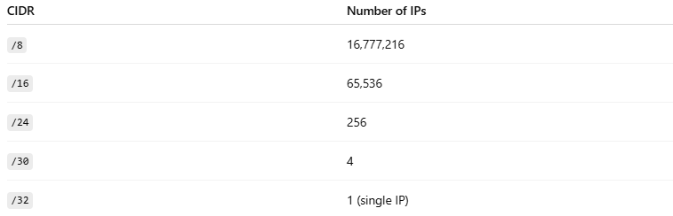

CIDR | Number of IPs
/8 | 16,777,216
/16 | 65,536
/24 | 256
/30 | 4
/32 | 1 (single IP)

✅ Summary
# Source: AI Source: Provided by: [Data Path: Persons Table -> ID Column: 1, Name_En Column: Motasem Essam] -> From: [ChatGPT] on [1/18/2026]
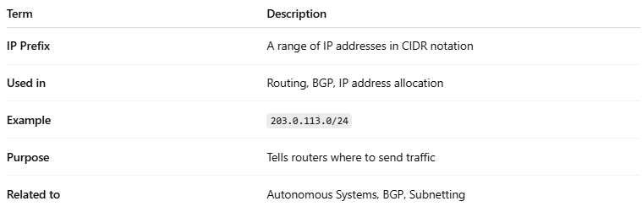

Term | Description
IP Prefix | A range of IP addresses in CIDR notation
Used in | Routing, BGP, IP address allocation
Example | 203.0.113.0/24
Purpose | Tells routers where to send traffic
Related to | Autonomous Systems, BGP, Subnetting

